CKAD

EQUIPE :BEJGANA ABDERAZZAK

REMERCIEMENTS

....

SOMMAIRE

REMERCIEMENTS 2
I. Introduction 4
I. Objectif 4
I. CKAD Curriculum 4
II. Application Design and Build 5
Pod 5
ReplicationController 6
Replicat set 6
DEPLOYEMENT 7
Namespace 7
Pour ajouter un Namespace: 7
Ajouter le pod sur un namespace : 8
Services 9
NodePort 9

- Introduction
L’objectif de ce document est de préparer le certificat CKAD
Certified Kubernetes Application Developer

- Objectif
Deux mois pour préparer ce certificat :
Date de passage : 5 janvier 2026

- CKAD Curriculum
Application Design and Build20%:
Define, build and modify container images
Choose and use the right workload resource (Deployment, DaemonSet, CronJob, etc.)
Understand multi-container Pod design patterns (e.g. sidecar, init and others)
Utilize persistent and ephemeral volumes
Application Deployment20%
Use Kubernetes primitives to implement common deployment strategies (e.g. blue/green or canary)
Understand Deployments and how to perform rolling updates
Use the Helm package manager to deploy existing packages
Kustomize
Application Observability and Maintenance15%
Understand API deprecations
Implement probes and health checks
Use built-in CLI tools to monitor Kubernetes applications
Utilize container logs
Debugging in Kubernetes

Application Environment, Configuration and Security25%
Discover and use resources that extend Kubernetes (CRD, Operators)
Understand authentication, authorization and admission control
Understand requests, limits, quotas
Understand ConfigMaps
Define resource requirements
Create & consume Secrets
Understand ServiceAccounts
Understand Application Security (SecurityContexts, Capabilities, etc.)

Services and Networking20%
Demonstrate basic understanding of NetworkPolicies
Provide and troubleshoot access to applications via services
Use Ingress rules to expose applications

Date de passage : 15 December 2025
- Application Design and Build

- Docker
- containerD

ctr : command plus bas pour manipuler sur containerD.
nerdctl provide a command like docker
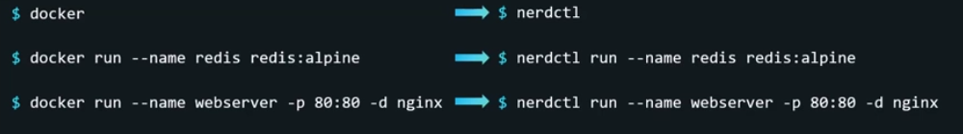

Pod

4 éléments sont nécessaires pour crée un Pod.
apiVersion: v1
kind: Pod
metadata:
name: myapp-pod

spec:

apiVersion: v1
kind: Pod
metadata:
name: mypod
labels:
env: prod
spec:
containers:
- name: nginx
image: nginx

kubectl run nginx --image=nginx --dry-run=client -o yaml

ReplicationController

apiVersion : v1
kind: ReplicationController
metadata:
name: myapp-rc
labels:
app: myapp
type: front-end

spec:
template:
metadata:
name: myapp-pod
labels:
app: myapp
type: front-end
spec:
containers:
- name: nginx-container
image: nginx
replicas: 3

Replicat set
Les paramètres qui sont changés par rapport au ReplicationControl sont en rouge :

apiVersion : apps/v1
kind: ReplicaSet
metadata:
name: replicat
labels:
app: myapp
type: front-end

spec:
template:
metadata:
name: myapp-pod
labels:
app: myapp
type: front-end
spec:
containers:
- name: nginx-container
image: nginx
replicas: 3
selector:
matchLabels:
type: front-end

DEPLOYEMENT

apiVersion : apps/v1
kind: Deployment
metadata:
name: deployement
labels:
app: myapp
type: front-end

spec:
template:
metadata:
name: myapp-pod
labels:
app: myapp
type: front-end
spec:
containers:
- name: nginx-container
image: nginx
replicas: 3
selector:
matchLabels:
type: front-end

kubectl create deployment --image=nginx nginx --dry-run=client -o yaml

kubectl create deployment --image=nginx nginx --dry-run=client -o yaml --replicas=4

Namespace
Il existe 4 namespace par défaut sur Kubernetes
- default
- kube-system
- kube-public

Pour ajouter un Namespace:
namespace.yaml
apiVersion: v1
kind: Namespace
metadata:
name: dev

kubectl apply -f namespace.yaml

Ou
kubectl create namespace prod

Ajouter le pod sur un namespace :
apiVersion : v1
kind: Pod
metadata:
name: mypod
namespace: prod
labels:
env: prod

spec:
containers:
- name: nginx
image: nginx

Ou
kubectl apply -f nginx.yaml --namespace=dev

Pour changer le namespace par defaut à un autre :
kubectl config set-context $(kubectl config current-context) --namespace=prod

Services

NodePort
Pour crée service, nous devons crée au premier un Pod ou déploiement :
Ci-dessous les caractéristiques :

- Le port interne de nginx est 80
- Les pod peux se connecter entre eux via :
  - ping 172.17.1.2
  - curl https://172.17.1.2
- Le node peux se connecter au Pod via ping et curl

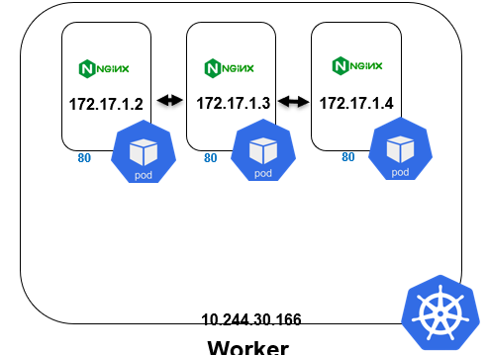

apiVersion: apps/v1
kind: Deployment
metadata:
name: nginx-deployment
spec:
replicas: 3
selector:
matchLabels:
app: nginx
template:
metadata:
labels:
app: nginx
spec:
containers:
- name: nginx
image: nginx:latest
ports:
- containerPort: 80

Pour crée un Service de type NodePort, il suffit de faire la déclaration suivante :
apiVersion: v1
kind: Service
metadata:
name: nginx-service
spec:
type: NodePort
selector:
app: nginx
ports:
- port: 80
nodePort: 30080

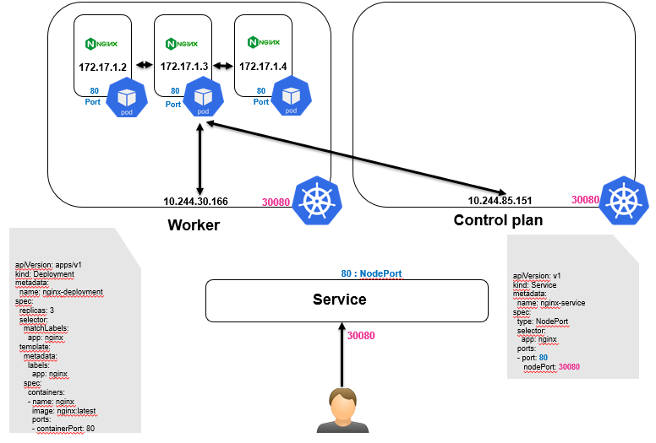

Ci-dessous les caractéristiques :
- Depuis les Pod, vous pouvez maintenant curler via le service :
  - curl https://nginx-service
- Depuis les Nodes , vous pouvez curler via IP/Port
  - curl http://10.244.30.166:30080
curl http://10.244.85.151:30080
NodePort : est le port entre service Kubernetes et service Nginx.
[à documenter]

kubectl expose pod nginx --port=6379 --name nginx-service --dry-run=client -o yaml

